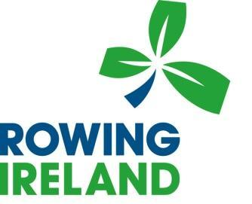

National Rowing Center Facility Assistant
Rowing Ireland is one of Ireland's foremost sporting organisations with a reputation for success and a strong tradition in sport and competition. Rowing Ireland is now seeking a Facility Assistant for our state-of-the-art rowing facility at Farran Woods in Co. Cork. The role will hold responsibility for the upkeep and maintenance of the facility. The successful candidate will to ensure the facility is constantly maintained.
This role requires a friendly, self-motivated individual that takes pride in their work. The position requires a person that has basic maintenance skills and experience in keeping a facility in a continuous state of operational and functional readiness.
This role will be a part time role (50% time).
Reporting to the Financial and Operations Lead, the responsibilities of the Facility Assistant will comprise of, and not be limited to:
Maintenance: The upkeep and monitoring of all internal building systems; water, heating, electric and sanatory services.
Course: Monitoring and adjusting international standard 2000-meter course. (Training and instruction in this function will be provided to the successful candidate).
Support: Supporting the team in the security and accessibility to the facility to resident athletes’ team, visiting crews. Facilitating of acceptance of deliveries and collections from suppliers.
Collaboration: Working to support the Strategic Business Lead and the Events Executive at the National Rowing Centre.
Competitions: Supporting competition organisers while they are preparing for and using the facility to deliver their activities.
Flexibility Adaptable and agile dealing with a range of competing priorities.

Additional Skills
Rowing: While Rowing knowledge is preferred it is not essential
Launch Driving: Some experience on operating a launch for use on the lake would be an advantage
Driving Licence: Full and clean driving licence is essential, experience and competency in towing would also be advantageous.
Requirements: All candidates must have existing valid permission to live and work in Ireland unrestricted.
The position will initially be on a part time flexible hours basis with possibility of weekend hours.
ADDITIONAL INFORMATION
Suitable candidates should apply in writing with a letter and current CV to ceo@rowingireland.ie. Queries may be directed to the above mail also.

Closing date for receipt of applications is Wednesday 2nd February, 2022.

Rowing Ireland is an equal opportunities employer, and all applications will be treated in strict confidence.

