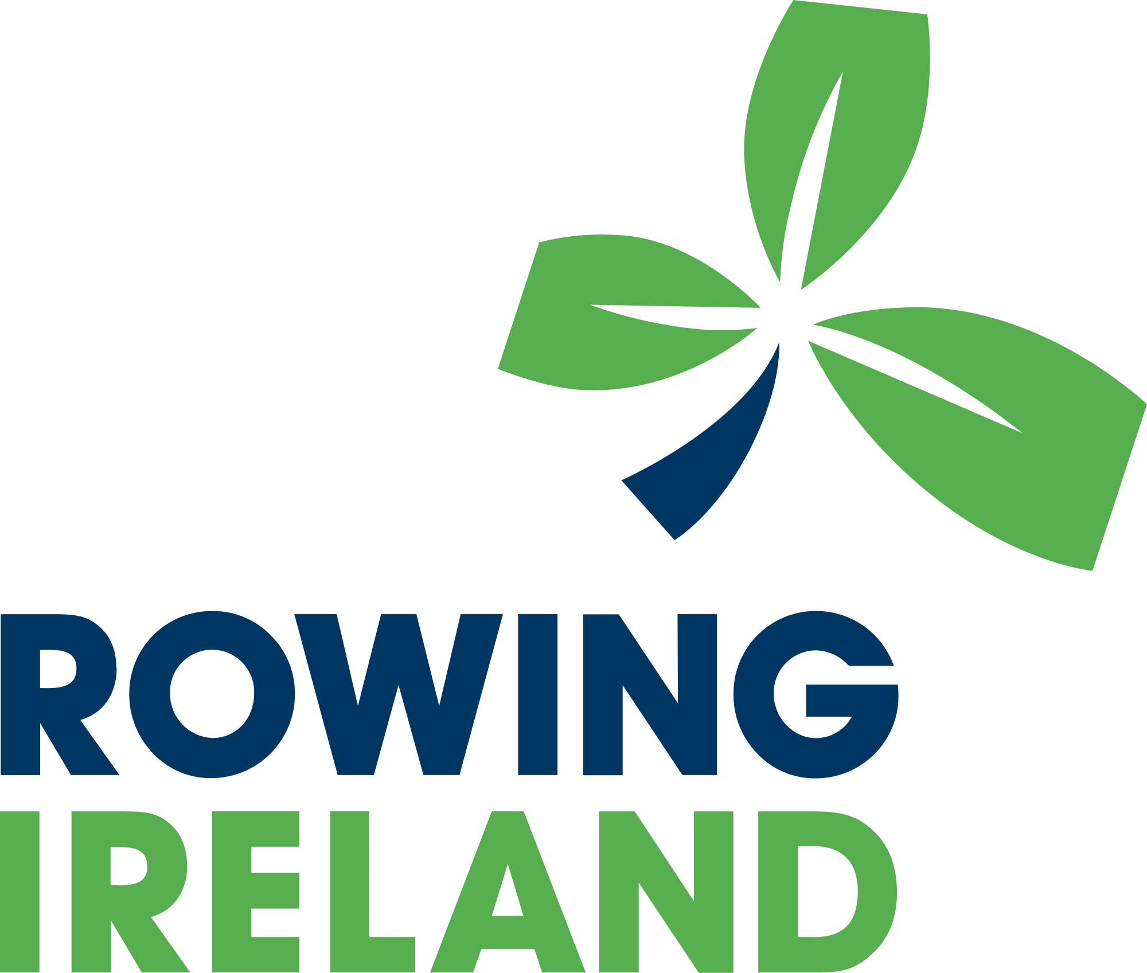

Athlete code of conduct and

Social media policy

Version | Date | Author | Changes
1.0 | June 2018 | M. Carpenter | New Version
1.2 | July 2021 | M Carpenter/Fran Keane | Updated to include new social media policy

Athlete Code of Conduct and

Social media Policy

Code of Conduct

- The following code of conduct should be adhered to by all athletes representing Rowing Ireland.
- As a responsible athlete representing Rowing Ireland, you will:
  - ∙ Respect the rights, dignity and worth of every athlete, coach, technical official and others involved in the sport and treat everyone equally. ∙ Uphold the same values of sportsmanship off the field as you do when engaged in rowing.
  - ∙ Cooperate fully with others involved in the sport such as coaches, technical officials, team managers, doctors, physiotherapists, sports scientists and representatives of the governing body in the best interests of yourself and other athletes.
  - ∙ Consistently promote positive aspects of the sport such as fair play and never condone rule violations or the use of prohibited or age-inappropriate substances
  - ∙ Anticipate and be responsible for your own needs including being organised, having the appropriate equipment and being on time. ∙ Adhere to the Rowing Ireland draft social media policy
  - ∙ Inform your coach of any other coaching that you are seeking or receiving.
  - ∙ Always thank the coaches and officials who enable you to participate in rowing.
As a responsible athlete, when participating in or attending any Rowing Ireland activities, including training/coaching sessions and competition events you will:
  - ∙ Act with dignity and display courtesy and good manners towards others. ∙ Avoid swearing and abusive language and irresponsible behaviour including behaviour that is dangerous to yourself or others, acts of violence, bullying, harassment and physical and sexual abuse. ∙ Challenge inappropriate behaviour and language by others. ∙ Never engage in any inappropriate or illegal behaviour.
  - ∙ Avoid destructive behaviour and leave rowing venues as you find them. ∙ Not carry or consume alcohol to excess and/or illegal substances. ∙ Avoid carrying any items that could be dangerous to yourself or others excluding rowing equipment used in the course of your rowing activity.

In addition, athletes, especially young athletes and vulnerable adults, should follow these guidelines on safe participation in rowing:
  - ∙ Notify a responsible adult if you have to go somewhere (why, where and when you will return)
  - ∙ Do not respond if someone seeks private information unrelated to rowing, such as personal information, home life information.
  - ∙ Strictly maintain boundaries between friendship and intimacy with a coach or technical official.
  - ∙ Never accept lifts in cars or invitations into homes on your own without the prior knowledge and consent of your parent/carer.
  - ∙ Use safe transport or travel arrangements.
  - ∙ Report any accidental injury, distress, misunderstanding or misinterpretation to your parents/carers and club Welfare officer as soon as possible.
  - ∙ Report any suspected misconduct by coaches or other people involved in rowing to the club welfare officer as soon as possible.
It should also be noted that when traveling abroad to represent Rowing Ireland internationally, the duty of care of the ends when the athlete’s designated flight lands back in Ireland. Should an athlete wish to take an alternative flight other than that organized by Rowing Ireland, the athlete should sign the attached form releasing them from the organisation’s care.

SOCIAL MEDIA POLICY
Social Media Policy and Scope
The term social media is used in relation to social networking sites that allow users to create personal profiles, share photos and videos, and communicate with others. Used correctly, social media enriches the value and perception of Rowing Ireland in the rowing community. Other messaging platforms, including SMS or emails used for similar purposes, can also be interpreted as social media.
Rowing Ireland will only have one account with FB, Twitter etc. The logo and Rowing Ireland brand will only be used on the official Rowing Ireland Facebook/Twitter etc pages. Authorisation to use the Rowing Ireland logo on a media medium must be given in advance by the CEO.
Rowing Ireland recognises key challenges with the use of social media amongst the rowing community:
● When members or volunteers share opinions online they may reflect positively or negatively on our organisation, individual staff, volunteers or members, and/or its stakeholders.
● In some cases, individuals or organisations outside of Rowing Ireland may use digital and social media to challenge Rowing Ireland's actions, rules and regulations. If necessary, Rowing Ireland will defend its position in such circumstances. This defence should follow consultation with the Rowing Ireland Communications Officer(s) and CEO.
● Rowing topics are widely discussed throughout all social media platforms. It is important that we can use these same, or similar, platforms to promote and outline official Rowing Ireland policies approved by the Rowing Ireland Board.
Rowing Ireland Staff members and Board members
Rowing Ireland staff and Board members must be conscious of their online activity, as there can be a blurred line between personal and professional online profiles. At all times Rowing Ireland staff and board members must be aware that their posts can be deemed to reflect the opinion and views of Rowing Ireland.
Staff Members /Board members/ Committee’s/Athletes using Personal Social Media Accounts:
- should avoid commenting on rowing related issues via social media, as their opinions can be interpreted as the views of Rowing Ireland.
- should be conscious of any personal content or activities that could be seen to be damaging to the reputation of Rowing Ireland or by association to its stakeholders; Sport Ireland, Sport NI or other sponsors,
- should at all times respect the brand, trademark, and copyrighted information and imagery of Rowing Ireland. Should consider comments they post relating to not only Rowing Ireland itself but also all key stakeholders linked to the organisation.

- Should re-post official Rowing Ireland content rather than create their own where possible. This content is to be made available to all of the above groups of people in a timely fashion at all global competitions.
- may be privy to confidential information that is not intended for the general public. They should be careful to not disclose information to others or online if it is not already available to the public.
- Data Protection Rules, Laws of Defamation and Libel Laws should be considered at all times. Recent court awards have confirmed that the Irish Libel Law extends to social media and what is posted online may render the individual liable to pay compensation if a case is lost.
- At all times online posts should be respectful of all individuals, races, religions and cultures and the fact that Rowing Ireland like many sports is an all-island sport. Disrespectful or discriminatory posts and/or comments on personal social media outlets not only reflect poorly on the individual commenting but also reflects negatively on Rowing Ireland, Sport Ireland and Sport NI.
Rowing Ireland Team Members (Rowers and Officials):
Having an active presence on social media is an everyday reality for most athletes and sportspeople, and indeed it presents a great opportunity; the chance to tell your own story, in your own words, but common sense and sound judgment must always be to the forefront when telling that story.
- Team Members and board members must obey the Code of Conduct, and adhere to the social media Policy.
- Most sports in Ireland are funded by Sport Ireland and/or Sport NI, and Sponsors who also require their governance codes to be met i.e., they expect a minimum level of etiquette in all communications (like social media).
- While representing Rowing Ireland be conscious that there is a division between personal comment and official duty. When in doubt of whether a post is personal or official – don’t post. When in doubt, leave it out.
- Rowers should not announce selection or non-selection until this information has been officially released by Rowing Ireland.
- Rowers should be conscious of a general confidentiality clause and be careful to not disclose information to others or online if it is not already available in the public.
- Data Protection Rules, Laws of Defamation and Libel Laws should be considered at all times. Recent court awards have confirmed that the Irish Libel Law extends to social media and what is posted online may render the individual liable to pay compensation if a case is lost. This remains a personal liability in most cases.
● For the duration of events, team members should not post information pertaining directly to team activities, team plans, or post contentious photos of other team members not only for privacy but also for security reasons.
Team Members should never post any negative comments online about:
❖ Fellow squad members
❖ Competitors
❖ Event organisers or sponsors
❖ Support staff
- Team Members should not use bad language in postings and should note that journalists may quote anything controversial that is posted and use it as a news story.
- Team Members should be appreciative on social media of those who support them e.g., family, coaches, support staff, sponsors and funders.
The golden rule is - ‘if you have nothing good to say, say nothing’. Younger athletes in particular could damage career prospects through ill-advised social media posts or unconsidered emails/texts etc.

Rules when responsible for the official Rowing Ireland Social Media channels:
- Team members should always remember that a positive spin can be put on every story, so even if Rowers are disappointed with their result, they should think of at least one plus to be gained and focus on that.
- If in any doubt, Team Members should check with their Team Manager before posting online, or responding to a post. If a conversation turns nasty report it immediately and block the offender.
- At all times Team members should respect the brand, trademark, and copyrighted information and imagery of Rowing Ireland.
- Team Members should never post embarrassing pictures or pictures of others without their permission.
- Team Members should never post photos of themselves or others in official clothing, or with the sponsor’s product, in compromising or derogatory contexts. Team Rowers should never be photographed in official clothing when behaving in an unprofessional or unsporting manner.
- When Rowing Ireland members contact Rowing Ireland through social media platforms such as Facebook and Twitter their queries should be addressed publicly if they are deemed serious; the response should be carefully worded, directing the query offline via direct messaging or to an email address. Discourage the public posting of personal information such as contact details.
- If a staff member becomes aware of posts on social media that include false allegations, a link to the correct information can be provided, or it can be raised with the Communications, Officer(s) or CEO.
- If a staff member or athlete suspects that a Rowing Ireland social media channel has been hacked notify the Communications Officer(s) or CEO immediately.
- If staff/committee members are representing Rowing Ireland in an official capacity, it is important that the posts convey the same positive, volunteer-led spirit that the organisation uses in all of its communications.
- Internet postings must respect copyright, privacy, fair use, financial disclosure, and other applicable laws.
- When posting from a Rowing Ireland social media account the first person should not be used. Use “we” rather than “I” at all times as your post is reflecting the view of the organisation.

Name in blocked capitals________________________
Signed _____________________________________
Date______________________________________
Parental/Guardian approval for u/19
Signed______________________________________
Name in blocked capitals____________________________
Relationship __________________________________________
I hereby wish to inform Rowing Ireland that I will be returning from
______________________________________________________________
Using my own transport and I have made those necessary arrangements myself or with my parents/guardians.
I agree that I am now released from the care of the Rowing Ireland team from: Time:_____________________
Date:____________________
Signed____________________________________

Parental/Guardian approval for u/19
Signed______________________________________ Name in blocked capitals____________________________ Relationship_________________________________________

Contents
Heading (Heading 2) 9

Heading (Heading 2)

Sub Heading (Heading 3)

Secondary Sub Heading (Heading 4)

Body text (Normal)

- Bullet points (Bullets)
  - Inset

- Numbered bullet points (Numbered Bullets)

