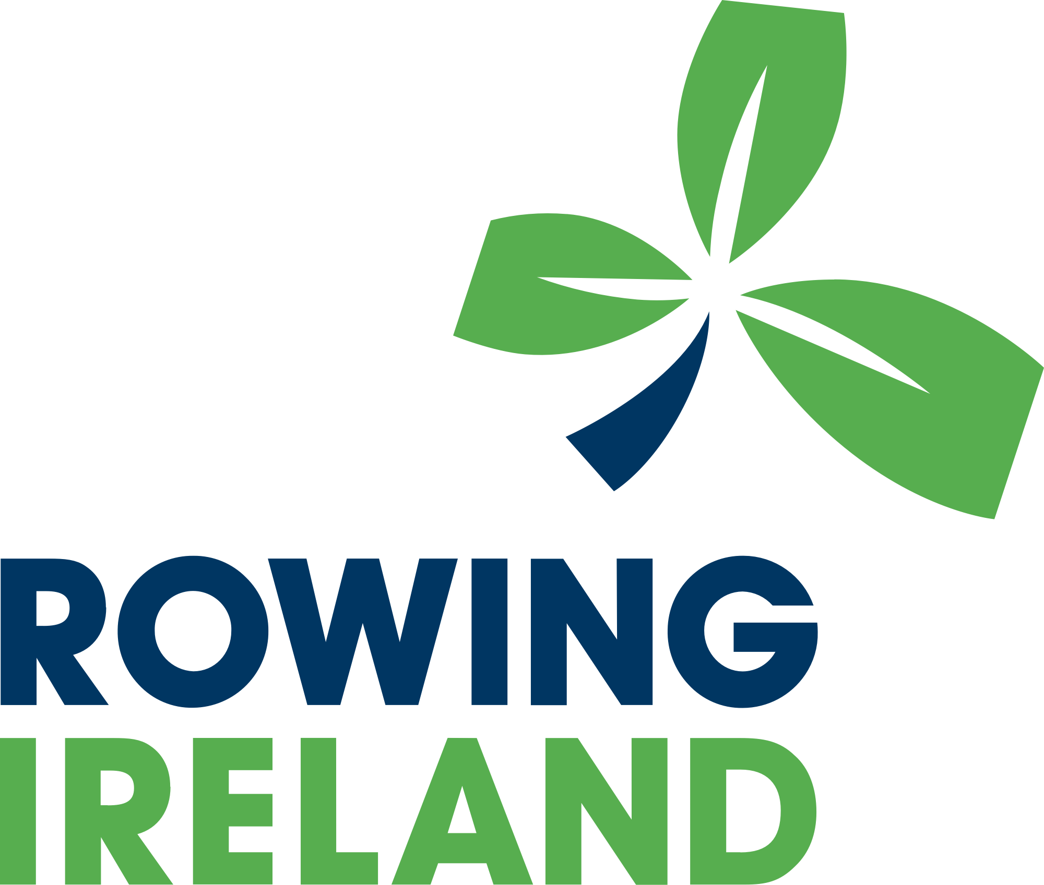

Privacy Notice for our Members

Version | Date | Author | Changes
1.0 | 11th April 2022 | M Carpenter | New version

Privacy Notice for Our Members

Rowing Ireland is committed to respecting the privacy of our members. This notice is to explain how we may use the personal information we collect before, during and after your membership with us, and what rights you have with us.

This complies with new laws coming into effect from May 2018.

We have appointed a Data Protection Compliance Manager who has overall responsibility for data protection compliance in our organisation. Contact details are set out in the "Contacting us" section at the end of this privacy notice. We have not appointed an official Data Protection Officer to oversee our compliance with data protection laws as we are not required to do so because we do not process large quantities of data.

Names of data controller | Rowing Ireland
Categories of personal data we collect | PERSONAL INFORMATION WE MAY COLLECT FROM YOU  You may provide us with or we may obtain personal information  about you, such as information regarding your:  - Name, title, gender, date of birth, email addresses and telephone numbers, signatures, membership start and end date; club membership number, references and other information included in a CV or cover letter or as part of the application process for membership;  - Other personal details that enable us to verify your identity and suitability for example coaching qualifications, passport copies, PPS / social services numbers, driver’s license;  - Details of next of kin, contacts and emergency contacts;  - Details of membership rowing club(s);  - Records of your interactions with us such as telephone conversations, emails and other correspondence;  - Any feedback you provide in a survey;  - Records of your entry into and attendance at any events, competitions or workshops delivered by us or our sports partners;  - Competition records of rankings and gradings at particular sporting events for research purposes;  - Records of training assessments and performance;  - Images in video and/or photographic form and voice recordings which we take ourselves or other people provide to us;  - Details that enable us to investigate and process and complaints or disciplinary matters in accordance with our rules;  - Payment or bank details so that we can receive payments from you for RI activities or you can receive funding from us and

details of the financial transactions with you;
- Subscription information: for example, when you subscribe to one of our newsletters or other materials.
Special Categories of personal data | We also store and use the following “special categories” of more sensitive personal information regarding:  - Any medical condition that might affect your performance of rowing activities, including details of allergies, tetanus vaccinations, and medications taken, and data gathered for anti-doping purposes
Our sources of the personal data | We obtain personal data when you:  - Register as a member with us and fill out our membership form;  - Contact us by phone, email or in any other means;  - Make a query on our website;  - Purchase any tickets or services from us;  - Register to attend an event / workshop run by us;  - Become involved in any complaints or disciplinary issue under our rules;  - Partake or compete in events run or facilitated by us,  - Are selected to participate in any squad run by us;  - Any third party references you provide as part of any application process with us; and  - Respond to our surveys or feedback forms
Automated decisions we may take | None
Purposes, and legal basis for which we process personal data | See Schedule 1
Who we will disclose your personal data to | We may disclose your personal data to the following:  - Any party approved by you;  - To any rowing related administrative body to allow them to property administer rowing on a local, regional, national and international level;  - Staff and Volunteers who work at venues to support the delivery of RI events;  - Business partners in order to provide services as required and/or requested by RI;  - Other service providers for example our membership system developers and / or servicer and our online score system developer and/ or servicer;  - National Vetting Bureau (for specific vetting purposes);  - Other government bodies, statutory authorities or regulators, where we are required to do so by law
Your right to withdraw consent | Where you have given your consent to any processing of personal data, you have the right to withdraw that consent at any time. If you do, it will not affect the lawfulness of any processing for which we had consent prior to your withdrawing it. The withdrawal of consent may impact your membership status with us as it would affect our ability to administer your membership and the sport of rowing.

Location of your personal data | We will not routinely transfer your personal data to countries outside the European Economic Area (EEA).  On the limited occasions when this does occur (for example, when we partake in international tournaments outside of the EEA) we will take all reasonable steps to ensure that our normal security measures and protections apply to accessing it.  If you require more details on the arrangements for any of the above, then please contact us using the details in the “Contact us” section below.
How long we will keep your personal data | We will not retain your personal data for longer than is reasonable and necessary for the purposes for which it was collected.  The specific length of time will depend on the type of information and the reason we collected it from you.  In the absence of any legal requirement, we generally retain all physical and electronic records for a period of 5 years after your last contact with us or the end of your membership, or your last contact with us.  In the case of Garda Vetting information, we will retain it for the life of the vet (i.e. a maximum of 4 years) and for 12 months after the renewal period has expired. For more information, please review our vetting procedures here.  Information that may be relevant to personal injury or discrimination claims may be retained until the limitation period for those types of claims has expired. Please note that the limitation periods might not start to run until a long time after your membership with us.
Your rights in respect of your personal data | You have the right of access to your personal data and, in some cases, to require us to restrict, erase or rectify it (if it is inaccurate or out of date, for example, if you change your email address) or to object to our processing it, and the right of data portability.  If you have any questions relating to your rights, please contact us by using the details set out in the "Contact us" section below.  More information about your legal rights can be found on the Office of the Data Protection Commissioner’s website at http://gdprandyou.ie/
Contact Us | mail. info@rowingireland.ie  phone. (01) 6251125  website. http://www.rowingireland.ie/
Complaints | If you have any concerns or complaints about how we are handling your data please do not hesitate to get in touch with the Data Protection Compliance Manager.

Changes to this Notice | We may update this privacy notice from time to time. When we materially change this notice, we will update the version date at the bottom of this page. For significant changes to this notice, we will try to give you reasonable notice unless we are prevented from doing so. Where required by law we will seek your consent to changes in the way we use your personal information.

SCHEDULE 1 - PURPOSE AND LAWFUL BASIS FOR PROCESSING YOUR PERSONAL DATA

Purpose for processing your personal data | Personal information used | Lawful basis
- To administer your membership with us, including your registration and any ongoing enquiries; | All contact details, records of your interactions with us, and marketing preferences. | This is necessary to enable us to properly manage and administer your account with us.
- To send you information we think you might find useful or which you have requested from us, including our newsletter and information about our events and the promotion of sport in Ireland, and services of value to you provided by our partners. | Contact details and marketing preferences. | As the National governing body for rowing in Ireland, we have a legitimate interest to provide you with information regarding rowing in Ireland, the promotion of rowing, and best practices in running your organisation.
- To administer bookings and your attendance at events and workshops; to carry out surveys and to analyse that data to better understand the needs of our members and any trends. | Records of attendance at any events run by us (and/or in conjunction with our partners).  Results of any surveys carried out (details will be anonymised to the extent possible) | We have a legitimate interest in doing so to ensure that our events continue to improve and are targeted and relevant, and to understand the requirements of our members.
- To administer rowing, to optimise team preparation and training and for statistical purposes. | - Competition records of rankings and gradings at particular sporting events; and records of training assessments and performance.
- Retention of records | All the personal information we collect. | We have a legitimate interest in retaining records whilst they may be required concerning complaints or claims. We need to retain records to properly administer and manage any  account you have with us and in some cases, we may have legal

or regulatory obligations to retain records.

For criminal records history, we process it based on legal
obligations or based on your explicit consent.
- To deal with your queries | Contact details and records of your interactions with us. | We have a legitimate interest to provide this service we provide.
- To promote rowing, and any campaigns/ work undertaken by Rowing Ireland. | Images in video and/or photographic form. | For legitimate interests of promoting rowing in Ireland and/ or where you have given us your explicit consent to do so.
- To make payments to you where we have agreed to fund a project | Transaction and payment data | This is necessary to make payments to you.
- To arrange for any trip or transportation to and from an event | Identification documents details of next of kin, family members and emergency contacts, transaction and payment information, health and medical information. | This is necessary to enable us to make the necessary arrangements for the trip and/or transportation to an event.  We process special category personal data based on your explicit consent
- To use information about your physical or mental health (including any injuries) or disability status, to ensure your safe participation in rowing | Health and medical information | We process special category personal data based on your explicit consent.
- To gather evidence for possible grievance or disciplinary hearings | All the personal information we collect | We have a legitimate interest in doing so to administer the sport and to manage the disciplinary and complaints process.
- The security of our IT systems | Your usage of our IT systems and online portals. | We have a legitimate interest to ensure that our IT systems are secure.
- To comply with legal obligations, for example, regarding people working with children or vulnerable adults. | Information about your criminal convictions and offences | For criminal records history we process it based on legal obligations or based on your explicit consent.

