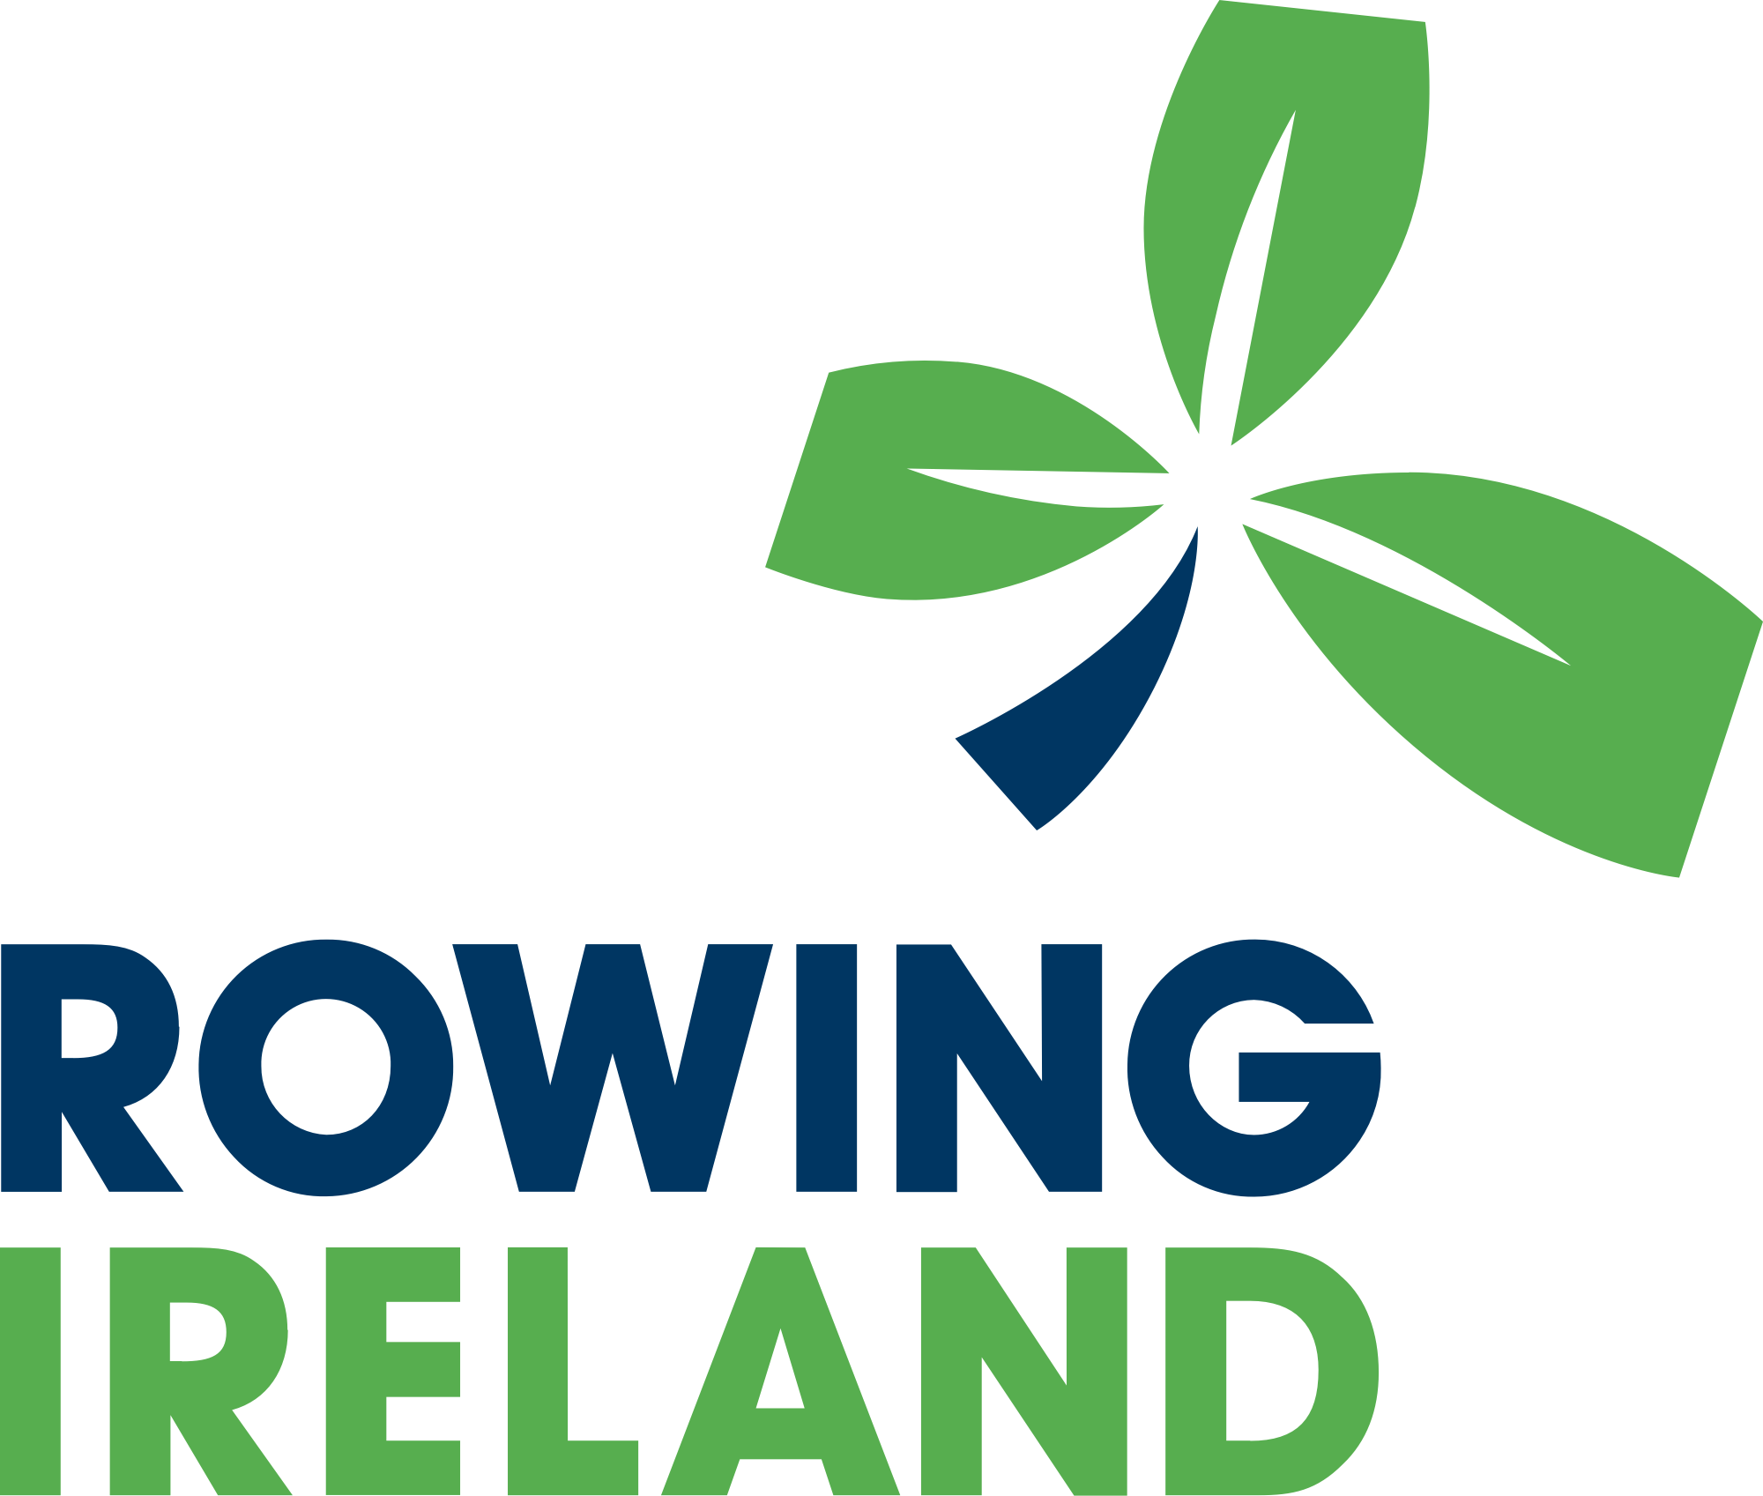

Privacy Policy

Version | Date | Author | Changes
1.2 | 11th April 2022 | M Carpenter

Privacy Policy
This statement discloses the privacy policy for www.rowingireland.com, the official website of Rowing Ireland, the national governing body for the sport of rowing in Ireland.

You do not need to give us any information about yourself to view the Rowing Ireland website. You can visit and view this site and all the latest news and results without telling us who you are or revealing any information about yourself. However, on occasions, Rowing Ireland needs to monitor website usage to help its development and our services.

Rowing Ireland is committed to protecting your privacy and ensuring a secure online experience.
Our website uses cookies. View our cookies policy on page 3.

Collection of Personal Data
Rowing Ireland offers certain functions and services which, if you choose to use them, will require information from you in order to work, including the option to contact us and to subscribe to receive a newsletter by email. You may need to provide some information about yourself to access these services such as your name, email address and mobile telephone number.

Use of Personal Data

We use personal information for these purposes:
- Responding to questions, feedback and requests for information or support
- To provide you with information or services that you request from us or to
provide you with information about other services we offer that are similar to those that you have already purchased or enquired about.
- Monitor customer traffic patterns and site usage to help us to develop the website and our services.
- To help us create and deliver content most relevant to you
- To maintain a record of your relationship with Rowing Ireland and your
- participation in any event, competition, training, course or otherwise with or on behalf of Rowing Ireland.
- Registering for a Rowing Ireland course, workshop or module
- If you register for a Rowing Ireland course, workshop or module we will use your details to provide and administer the course, any relevant assessments and to confirm results and or issue certificates.
- Images or videos taken at events, competitions or training may be used for Rowing Ireland marketing purposes, including social media posts.
- We employ other companies and individuals to perform functions on our behalf such as credit card payments and designing and operating our website. Such companies and individuals have access to your personal information for the purpose of carrying out this work only. These enterprises will not use your data for any other purpose.

Business Relationships
Our website contains links to other third-party websites and we also participate on social media websites including, but not limited to Facebook, Twitter, YouTube, Instagram, Snapchat & LinkedIn. We may share content from websites such as these on the Rowing Ireland site however, we do not control the privacy practices of such websites. For further information, you should refer to the relevant third-party website’s privacy policy. Rowing Ireland is not responsible for the privacy practices or the content of external websites.

Subscribing to receive our news by email

If you subscribe to receive a Rowing Ireland newsletter, we will use your email to send you the requested publication(s). We use MailChimp, a US-hosted third-party provider to send out and monitor our communications who are certified as adhering to the EU-US Privacy Shield. For more information, please see MailChimp's Privacy Policy. If you no longer wish to receive these emails, you can unsubscribe directly on our website or by following the instructions in the relevant communication.

Other lawful reasons for using information about you
We will not share any information you have provided without your consent unless there is a legal or other legitimate reason to do so or it is necessary to provide the service you have requested.
We may need to process information about you to comply with applicable laws and protect our legitimate interests and legal rights, including, but not limited to, use in connection with legal claims, compliance, regulatory, investigative purposes (including disclosure of such information in connection with legal process or litigation).

Changes to the privacy policy
We keep our privacy notices under regular review. This privacy notice was last updated on 2/10/2020.

Cookie Policy

What is a Cookie?
Cookies are small text files that are stored on your PC, phone or other web-enabled devices when you visit the Rowing Ireland website. They are not harmful and do not contain any personal or confidential information such as your home address, date of birth or credit card details.

A cookie asks your browser to be stored on your device in order to remember information about you, such as your language preference or login information. Those cookies are set by us and called first-party cookies. We also use third-party cookies – which are cookies from a domain different from the domain of this website – for our ticketing system and marketing efforts.

How are cookies used?
Cookies are needed to help provide you with a quick, responsive and personalised web experience. Cookies allow the website to remember actions that you have performed on the site, your preferences and the pages you have visited. They also tell the site that you have returned. Some aspects of the website cannot function effectively without using cookies.

How does the Rowing Ireland website use cookies?

Strictly Necessary Cookies
These cookies are necessary for the website to function and cannot be switched off in our systems. They are usually only set in response to actions made by you that amount to a request for services, such as setting your privacy preferences, logging in or filling in forms. You can set your browser to block or alert you about these cookies, but some parts of the site will not then work. These cookies do not store any personally identifiable information.

Performance Cookies
These cookies allow us to count visits and traffic sources so we can measure and improve the performance of our site. They help us to know which pages are the most and least popular and see how visitors move around the site. All information these cookies collect is aggregated and therefore anonymous. If you do not allow these cookies we will not know when you have visited our site, and will not be able to monitor its performance.

Functional Cookies or Third-party cookies
These cookies enable the website to provide enhanced functionality and personalisation. They may be set by us or by third party providers whose services we have added to our pages e.g. Future Ticketing. If you do not allow these cookies then some or all of these services may not function properly.

Targeting Cookies
These cookies may be set through our site by our advertising partners. They may be used by those companies to build a profile of your interests and show you relevant adverts on other sites. They do not store directly personal information but are based on uniquely identifying your browser and internet device. If you do not allow these cookies, you will experience less targeted advertising.

Social Media Cookies
These cookies are set by a range of social media services that we have added to the site to enable you to share our content with your friends and networks. They are capable of tracking your browser across other sites and building up a profile of your interests. This may impact the content and messages you see on other websites you visit. If you do not allow these cookies you may not be able to use or see these sharing tools.

Managing your cookie preferences
Our website uses cookies to improve your browsing experience and provide the information we believe might be of interest to you. When visiting our website you have the option of clicking “Accept All Cookies” to agree to the storing of cookies on your device to enhance site navigation, analyse site usage, and assist in our marketing efforts or you can choose “Cookie Settings” to manage your cookie preferences. This option will display a navigation panel on your screen where you can learn about the cookies we use, their function and choose whether you want to enable or disable them. You can access the Cookie Settings whenever you wish to change your preferences.

Deleting cookies
Information on deleting or controlling cookies is available at www.allaboutcookies.org. However please note that if you do this you may not be able to use the full functionality of this website.
Your browser software should however enable you to block cookies if you wish to, please refer to the instructions for your file management software to locate the file or directory that stores cookies.

Consent
By using the Rowing Ireland website, you consent to the collection and use of any information you provide to us for the purposes described above. If we amend our privacy policy, any changes will be published on this website. If at any time you wish to update the information which we hold about you, or if you wish to stop receiving information from Rowing Ireland, please contact us.

