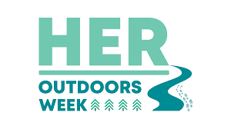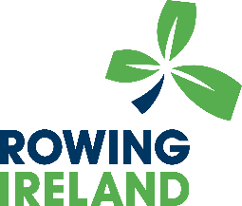

Her Outdoors Week 8th – 14th August 2022

Event funding application

Club: _______________________________________________________

Name, date and description of event: ____________________________ eg. Camp, adventure row day out, tour, try rowing day
Location of event:

Expected number of participants:

Contact details for event organiser (email and phone number):

Funding request to support event:

Item | Cost
Example: T-shirts for participants | 10 euro per participant
Example: Coaches for event | 10 euro per participant

Conditions of application: Club will be required to display the Heroutdoors event branding at the event and provide receipts where necessary.

Please submit this form to womeninsport@rowingireland.ie

