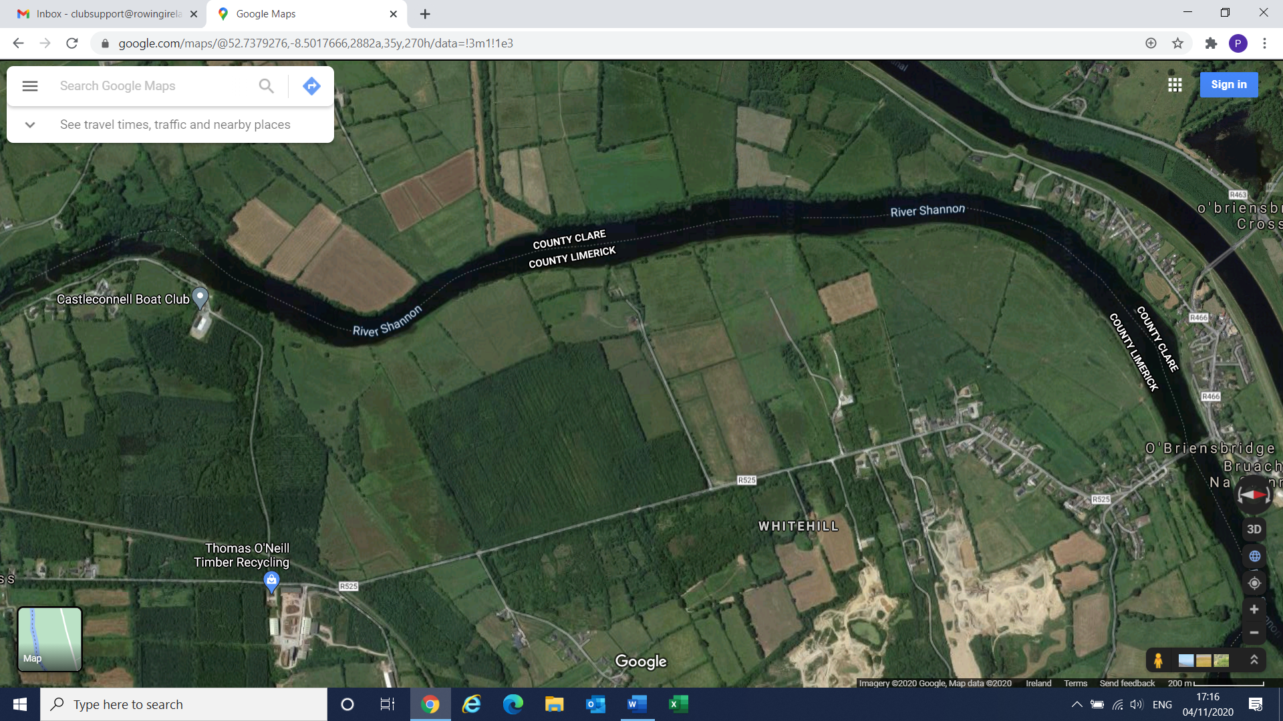

***In case of Emergency Dial 999 or 112, ask for Fire Service, Ambulance or River Rescue, give nearest Eircode for location!***

**Castleconnell Boat Club Emergency Action Plan Emergency Services Rendezvous Points**