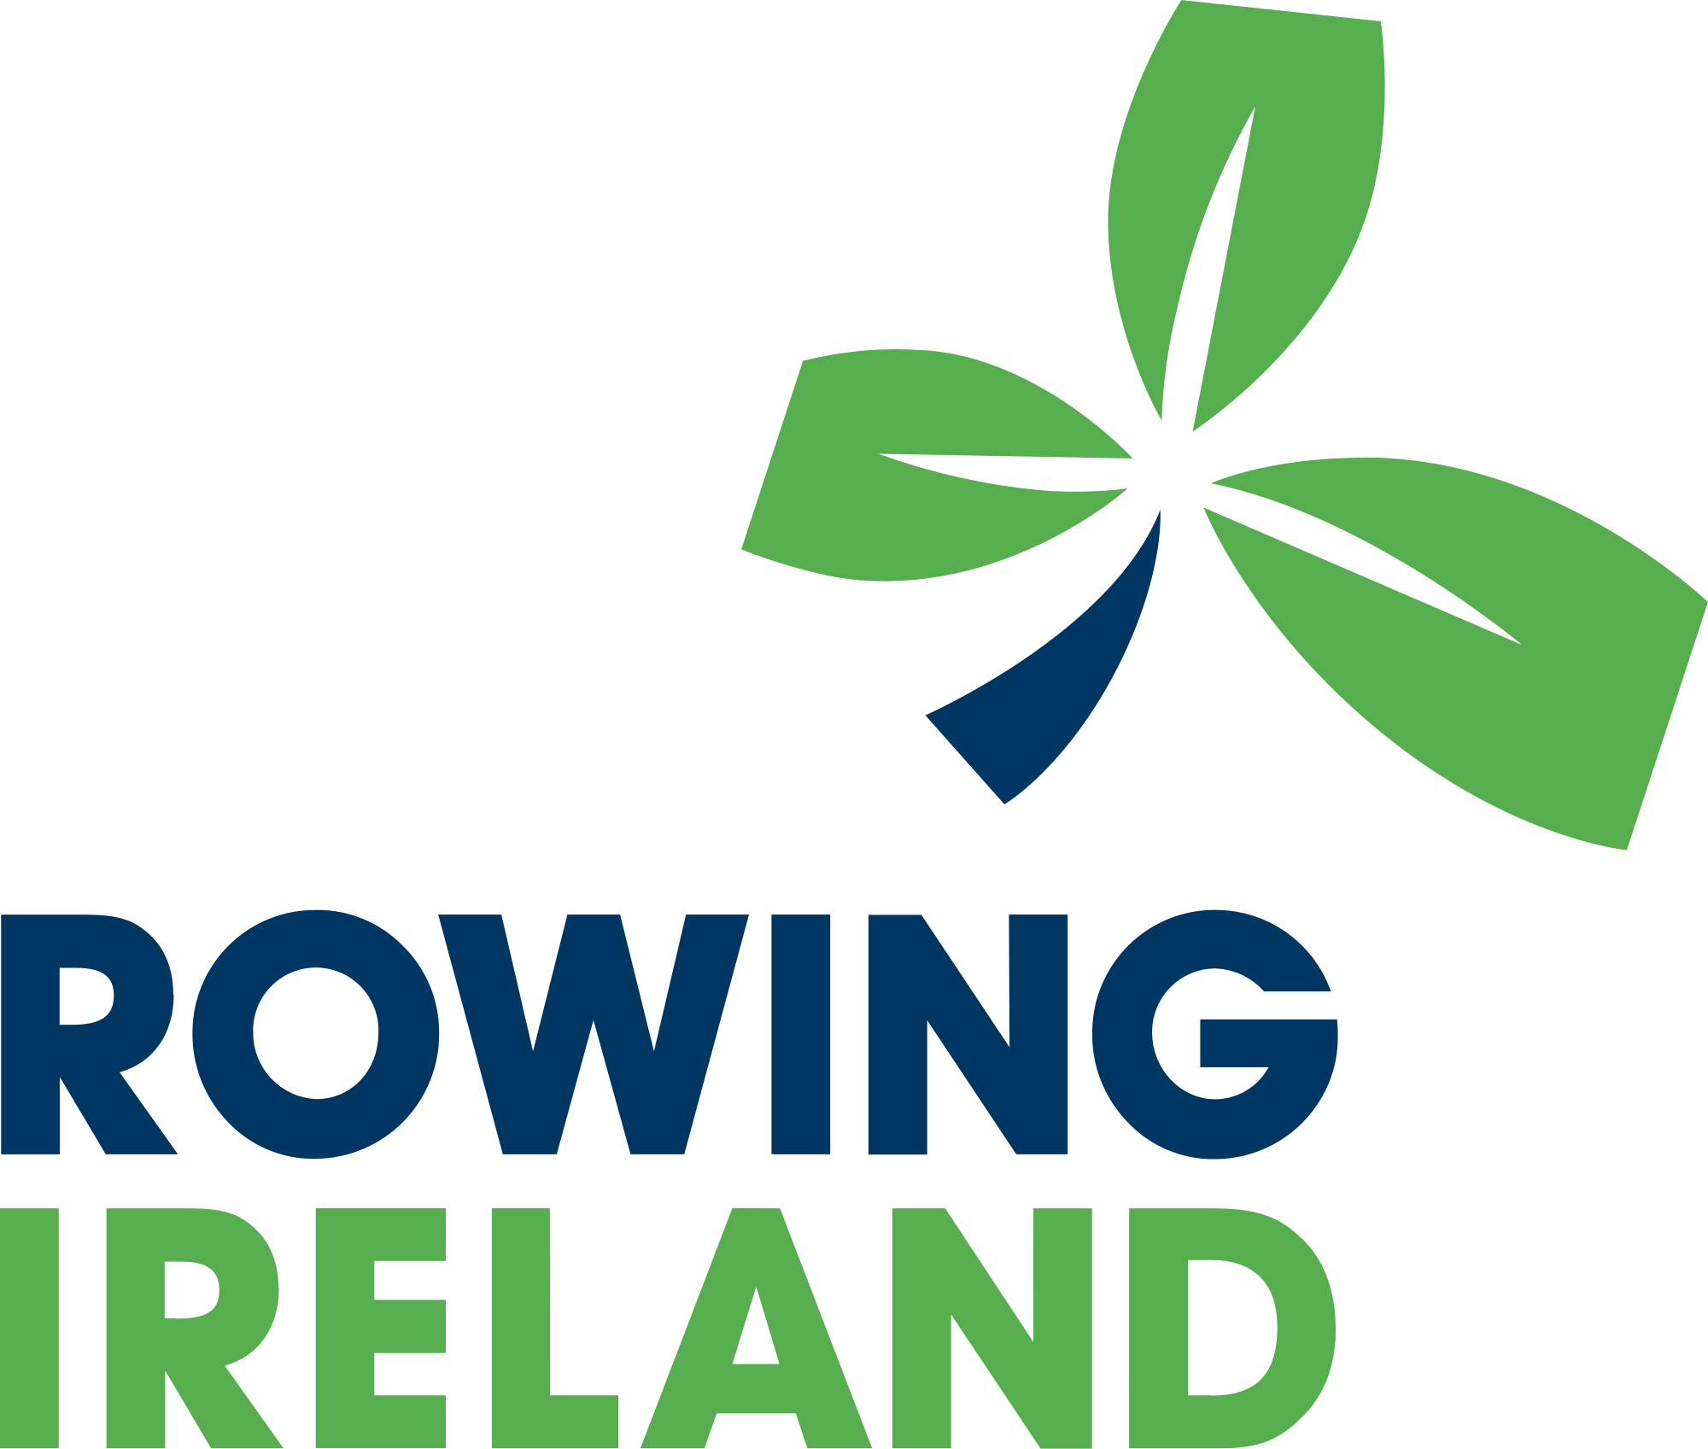

NOTICE OF 2023 AGM

Friday, 14th April 2023

Dear Secretary,

The Annual General Meeting of the Irish Amateur Rowing Union Company Limited by Guarantee (t/a Rowing Ireland) will be held both in person and online on Sunday May 7th from 10:30 a.m. until 12:00 pm at the Conference Centre, Sport Ireland Campus, Blanchardstown, Dublin.

Relevant reports will be issued to club secretaries within seven days of this notice.

The business of the AGM shall include:

- the minutes of the last AGM, and matters arising;
- the 2022 Report of the Secretary (annual report) presented by the President Neville Maxwell;
- the receipt of nominations and election of eligible Directors (5 No.);
- an update from the safety advisory committee;
- the Financial Report for 2022 presented by Grant Thornton;
- the appointment of Company auditors for 2023; and,
- an update from the High Performance Programme

Instructions for registration will be issued to your club secretary in the next week.

Please note that it is proposed that the fixtures meeting will be held at an EGM following further consultation with clubs and event secretaries.

Kind regards,
Nessa Foley,
Company Secretary

